Instructions on how to use this template

Please delete this instruction (as well as the following sample text) before you start entering your text on the next pages. 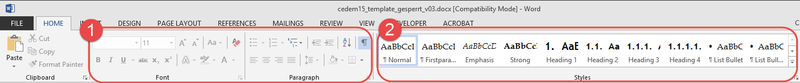In order to assure a time-efficient workflow, formatting in this document is restricted to pre-defined styles. Therefore in the Home-Ribbon in Word all icons for manual formatting are disabled (1).

Please use the pre-defined styles*[1]* (please see illustration above) which offer a variety of formatting possibilities.

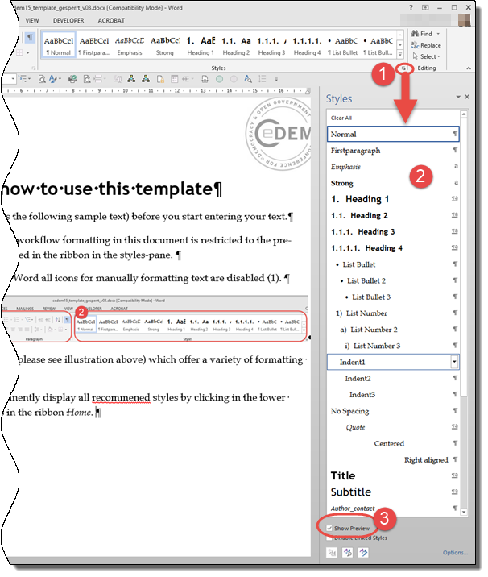In order to apply a style either select word or paragraphs and then assign the desired style. The sample text on the following pages shows you proposed styles [in square brackets].

Furthermore you can also permanently display all recommended styles by clicking in the lower right corner of the group Styles in the ribbon Home (see illustration on the right (1))

The Styles pane will appear (2). You can display a preview for all styles by clicking Show preview (3) which makes it easier to select the proper style.

You can also see which style is selected for a word/paragraph by clicking in this paragraph/word. Then the relevant style is highlighted in the styles pane.

Article Title [Title]

First name Last name [Subtitle]

Address, e-mail [Style: Author_contact]

Abstract: [maximum 150 words; Style: Abstract etc.] Sample text abstract text abstract text abstract text abstract text abstract text abstract text abstract text abstract text abstract text abstract text abstract text abstract text abstract text abstract text abstract text abstract text abstract text abstract text abstract text

Keywords: [maximum 5 words; Style: Abstract etc.] Keyword, keyword, keyword, keyword, keyword,

Acknowledgement: [Style: Abstract etc.] Acknowledgement text … text text Acknowledgement text … text text Acknowledgement text … text text Acknowledgement text … text text

# Heading 1 [Style: Heading 1]

[Style: Firstparagraph] Nunc viverra imperdiet enim. Fusce est. Vivamus a tellus. Pellentesque habitant morbi tristique senectus et netus et malesuada fames ac turpis egestas. Proin pharetra nonummy pede. Mauris et orci.

[Style: Article_Normal]: Lorem[2] ipsum dolor sit amet, consectetuer adipiscing elit. Maecenas porttitor congue massa. Fusce posuere, magna sed pulvinar ultricies, purus lectus malesuada libero, sit amet commodo magna eros quis urna. Nunc viverra imperdiet enim. Fusce est.

## Heading 2 [Style: Heading 2]

Lorem ipsum dolor sit amet, consectetuer adipiscing elit. Maecenas porttitor congue massa. Fusce posuere, magna sed pulvinar ultricies, purus lectus malesuada libero, sit amet commodo magna eros quis urna. Nunc viverra imperdiet enim.

Fusce est. Vivamus a tellus. Pellentesque habitant morbi tristique senectus et netus et malesuada fames ac turpis egestas. Proin pharetra nonummy pede.

### Heading 3 [Style: Heading 3]

Lorem ipsum dolor sit amet, consectetuer adipiscing elit. Maecenas porttitor congue massa. Fusce posuere, magna sed pulvinar ultricies, purus lectus malesuada libero, sit amet commodo magna eros quis urna. Nunc viverra imperdiet enim. Fusce est. Vivamus a tellus.

Pellentesque habitant morbi tristique senectus et netus et malesuada fames ac turpis egestas. Proin pharetra nonummy pede. Mauris et orci. Aenean nec lorem. In porttitor. Donec laoreet nonummy augue.

#### Heading 4 [Style: Heading 4]

Lorem ipsum dolor sit amet, consectetuer adipiscing elit. Maecenas porttitor congue massa. Fusce posuere, magna sed pulvinar ultricies, purus lectus malesuada libero, sit amet commodo magna eros quis urna.

As Niklas Luhmann (1988) has shown....

“[Style: Article_Quote] Allocative resources refer to capabilities - or, more accurately, to forms of transformative capacity - generating command over objects, goods or material phenomena. Authorative resources refer to types of transformative capacity generating command over persons or actors” (Giddens, 1984, p. 33).

One might classify non-voters into three types: the dissatisfied, the interested, and the uninterested type (see Figure 1).

Figure 1: [Style: Caption] Types of Non-Voters

j0299125

Lorem ipsum dolor sit amet, consectetuer adipiscing elit. Maecenas porttitor congue massa. Fusce posuere, magna sed pulvinar ultricies, purus lectus malesuada libero, sit amet commodo magna eros quis urna.

Nunc viverra imperdiet enim. Fusce est. Vivamus a tellus.

Table 1: [Style: Caption] Facebook and Twitter Enquiry Response Rates – the following table uses the table style cedem_table

|  |  |  |
| --- | --- | --- |
| Year | Facebook | Twitter |
| 2010 | 50% | 0% |
| 2011 | 35% | 30% |
| Total | 86% | 30% |

Lorem ipsum dolor sit amet, consectetuer adipiscing elit. Maecenas porttitor congue massa. Fusce posuere, magna sed pulvinar ultricies, purus lectus malesuada libero, sit amet commodo magna eros quis urna.

This is a sorted list:

1. List number level 1 [Style: 1) List Number]

[Style: Indent 1] Lorem ipsum dolor sit amet, consectetuer adipiscing elit. Maecenas porttitor congue massa. Fusce posuere, magna sed pulvinar ultricies, purus lectus malesuada libero, sit amet commodo magna eros quis urna.Item

1. List number level 2 [Style: a) List Number2]

[Style: Indent 2] Lorem ipsum dolor sit amet, consectetuer adipiscing elit. Maecenas porttitor congue massa. Fusce posuere, magna sed pulvinar ultricies, purus lectus malesuada libero, sit amet commodo magna eros quis urna.Item

* + 1. List number level 3 [Style: i) List Number3]

[Style: Indent 3] Video provides a powerful way to help you prove your point. When you click Online Video, you can paste in the embed code for the video you want to add. You can also type a keyword to search online for the video that best fits your document.

And this is a bulleted list:

* List bullet level 1 [Style: • List Bullet]

[Style: Indent 1] Lorem ipsum dolor sit amet, consectetuer adipiscing elit. Maecenas porttitor congue massa. Fusce posuere, magna sed pulvinar ultricies, purus lectus malesuada libero, sit amet commodo magna eros quis urna.Item

* List bullet level 2 [Style: • List Bullet2]

[Style: Indent 2] Lorem ipsum dolor sit amet, consectetuer adipiscing elit. Maecenas porttitor congue massa. Fusce posuere, magna sed pulvinar ultricies, purus lectus malesuada libero, sit amet commodo magna eros quis urna.Item

* List bullet level 3 [Style: • List Bullet3]

[Style: Indent 3] Video provides a powerful way to help you prove your point. When you click Online Video, you can paste in the embed code for the video you want to add. You can also type a keyword to search online for the video that best fits your document.

And this is a normal text again.

References

[Style: References] Chadwick, A. (2006). Internet Politics: States, Citizens, and New Communication Technologies. Oxford: Oxford University Press. (Style ArticleReferences)

Heeks, R. (2006). Implementing and Managing eGovernment. London: Sage Publications.

Mingers, J. (1996). A Comparison of Maturana's Autopoietic Social Theory and Giddens' Theory of Structuration. Systems Research, 13(4), 469-482.

Wolfram, D., & Spink, A., & Jansen, B. J., & Saracevic, T. (2001). Vox populi: The public searching of the Web. Journal of the American Society for Information Science and Technology, 52(12), 1073-1074.

Coleman, S. (2000). Parliament in the Information Age: The Case of Westminister and Holyrood. In R. Gibson & S. Ward (Eds.), Reinvigorating democracy? British Politics and the Internet (pp. 67-80). Farnham, Surrey: Ashgate Pub Ltd.

Macintosh, A., & Whyte, A. (2006). Evaluating how ePariticipation changes local democracy, eGovernment Workshop 11 September 2006, Brunel University, West London. Retrieved July 31, 2008, from www.iseing.org/egov/eGOV06/Accepted%20Papers/624/CRC/Evaluation%20of%20eParticipationv-v2-submitted.pdf

About the Author

Firstname Lastname

[Style: Author_Text] Firstname Lastname works as the chair for public sector and business informatics at … Germany. After her Bachelor’s degree in Marketing Management from the … She speaks all the respective languages and strives to achieve the same in Arabic.

1. More information on how to use styles in Microsoft Word can be found here: <https://support.office.com/en-US/article/Style-basics-in-Word-D38D6E47-F6FC-48EB-A607-1EB120DEC563>
2. Text build with =lorem(x,y)